US National Hot Air
Balloon Championship, Great Texas Balloon Race Young Guns and
Great Texas Balloon Race
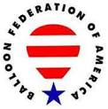

Operations Manual

June 12 - 18, 2023
Longview, Texas
Purpose

This manual is submitted as a part of an application for a waiver of Title 14 of the Code of Federal Regulations (14 CFR) part 14 CFR Part 91: §91.119 (b) and (c) by Sam Parks for the US National Hot Air Balloon Championship and the Great Texas Balloon Race (GTBR). Balloon flights will run between June 12 and June 18, 2023.

§91.119 (b) and (c) Minimum Safe Altitudes

The waiver will allow officially registered balloons to operate at an altitude of no less than 500 feet above the highest obstacle within a 500-feet horizontal radius of the balloon enroute to the target within a 10-nautical mile radius of the designated launch field or goal.

It will also allow for officially registered balloons to operate at 75-feet AGL above spectators and to set goals and/or targets at a minimum distance of 200 feet from physical barriers provided for spectator control.

The waiver will also allow officially registered balloons to descend to the surface over open water or sparsely populated areas including declared targets, but no closer than 200 feet from any person, vessel, vehicle, or structure.

No waiver is requested nor is waiver required by 14 CFR for any mass ascensions or pilot choice launches or final landings made in compliance with the BFA Competition Rules, as they are considered necessary for take-off and/or landing.

Duties, Staff and contact numbers

Organizer & Event Director Bill Bussey 903 235 4851
Championship Director (& FAA Liaison) Sam Parks 505 280 0637
Deputy Director Andy Baird 734 645 5783
Steward Henry Rosenbaum 804 971 0704
Chief Safety Official Bruce Bussey 903 452 5411
Assistant Chief Safety Officer Kelly Bussey 432-234-6738
Chief Scoring Official JC Smith 269 317 2768
Assistant Scoring Official Patty Cramer 740 502 0677
Chief of Measuring Teams Mark Dulweber 903 238 4484
Chief Scoring Officer GTBR & YG Dave Endres 608 219 9112
GTBR & Young Guns Steward Allen Yost 708 987 2129
Officer Manager Christy Bussey 903-521-3633
Chief Weather Official Brad Temeyer 605 261 9233
Assistant Chief Weather Duncan Dunavent 704 928 7882
Jury President John Davis 303 877 0935
Landowner Relations John Rich 903 720 3616
Propane Supplier Matheson Gas 903 686 1420
Balloon Repair of East Texas Joe Paddie 903 297 0003

Pilot Schedule

Responsibilities and Procedures

Registration and Airworthiness Determination
Balloons flown at the event must have current certificates of registration and airworthiness, or in place of the latter, an equivalent document from the Federal Aviation Administration. Specific certificate/airworthiness standards are as follows:
The aircraft may be certificated in any category, including experimental, provided the requirements of 14 CFR §91.7, §91.203, and §91.715 are met. FAA personnel may perform spot or ramp inspections.

Foreign registered balloons that do not possess an airworthiness certificate issued by the country of registration (as required by 14 CFR §91.203), must have a Special Flight Authorization issued by the FAA prior to registration at the event.

While operating, the balloon must have within it all documents required by the applicable regulations.

The competition rules cover procedures for balloons damaged or otherwise made unairworthy during the event. Throughout the event, the Safety Officer or his designees, and appropriate FAA personnel, will be consulted as necessary.

The organizer will maintain a roster containing the name, address, certificate number and date of last flight review of each registered pilot and the registration number, manufacturer, model and date of aircraft annual inspection of each aircraft participating in the event. A copy of each list is provided with the attachments and updates will be available at on-site registration. Facilities for FAA personnel to monitor operations during registration and all scheduled balloon events will be provided.

All pilots are required to register in advance of any practice flights and full registration along with document examination will be the afternoon of June 12, 2023. At this registration, they will be required to show photo ID and currency as well as any missing or outdated items not provided electronically.

Pilot Qualifications
Pilots must be officially registered with the US National Hot Air Balloon Championship and GTBR.

Each pilot must hold the appropriate pilot certificate (Private or Commercial) with Lighter-Than-Air Category and Free Class Rating. Each pilot must show evidence of current Flight Review (14 CFR part 61, §61.56) and must show evidence of currency per §61.57.

Pilot/Crew Briefing Procedures
All pilots are required to sign a statement indicating that they have read and understand the provisions of the waiver and the official Championship and GTBR rules prior to any competitive flight.

Event flight crewmembers carried on board a balloon during the event must have been briefed by the pilot of the balloon and must attend the pilot briefing for that flight. Each event flight crewmember must sign the waiver form supplied by the pilot. Each event flight crewmember must attest that they have attended the applicable pilot briefing(s) and have read and understand the conditions of the waiver.

Before each flight all pilots must attend the flight safety briefing. The competition rules provide details of all briefings and major details of the general and flight briefings are provided here.

Briefings
General Briefing: In accordance with the FAA issued Waiver each pilot flying in the event must attend the General Briefing scheduled for 7:00 PM June 12, 2023, at Maude Cobb. This briefing will review the Waiver and other pertinent information to help ensure safe conduct during the event. An electronic notice board (ENB) will be utilized to assist with outlining the major provisions of this waiver, balloon operations manual and competition rules and will be made available for all pilots to view prior to General Briefing in person attendance.

Flight Briefing: Attendance at the applicable pilot briefings are mandatory and will be conducted as indicated on the Pilot Schedule.

Safety
All meteorological reports, forecasts, and other safety or navigational information are provided in good faith for the guidance of participants. The organizer and official staff assume no responsibility for the completeness or accuracy of such information. It is the pilot’s decision whether to rely on that information or acquire additional information pursuant to 14 CFR §91.103.

Responsibility
Each Pilot has full and complete authority over the balloon and is responsible for all decisions to be made associated with the balloon on the ground and in the air. Each Pilot must ensure that his crew, his equipment, and his own level of skill and experience are suitable for the conditions in his own judgment. The Pilot is responsible for all the actions of his crew during the event.

Conduct
Pilots and their crews are required to behave in a sportsmanlike manner and to comply with the directions of the Event Officials. Profanity or unsportsmanlike conduct directed at any Official or volunteer will be penalized and may be grounds for expulsion of the pilot from the event.

Letter of Agreement / Statement of Responsibility
PIC Responsibilities
Each pilot has signed a letter of agreement and statement of responsibility acknowledging their responsibilities under the FAR’s as related to the US National Hot Air Balloon Championship and GTBR.

Acknowledgement
Pilots must know, understand and abide by all of 14 CFR, US National and HACD rules and regulations, including any rules that are added or modified during the event and announced during any official pilot briefing. All pilots, aircraft owners and operators agree to have liability insurance as required by the organizer in effect throughout the event.

Release of Liability
The Participant, by entering the event, agrees that the organizers and sponsors of this event, competition officials, officers, trustees, agents and/or members of these entities are providing the Participant with the facilities and means for participation in this event and in no way do they supersede the responsibility of the pilot in command as stated in 14 CFR, or otherwise.

Liability to Third Parties
By entering the event, a Participant assumes all liability for injury, loss or damage to third parties or their property caused by himself or his crew.

Event Flightcrew
Member Qualifications, Experience, and Maximum Numbers On-Board Each Balloon for each Type of Event
Event flightcrew must be briefed as to duties by the pilot in command and attend the pre-flight safety briefing. Only the number of event flight crewmember(s) specified by the respective balloon flight manual may be carried in each balloon during the flight.

Event Documentation
All relevant registration files, task data sheets, pilot registration information, etc., will be maintained by the organizer at least 60 days after the event and will be made available to the FAA Monitor upon request. Competition maps will be made available to the FAA Monitor at the time of pilot on-site registration or the general pilot briefing. Digital versions (pdf) of the competition map will be sent via email upon request.

GROUND OPERATIONS

Clear Areas
Clear areas are established at each target site. These areas are kept clear of spectators and are flagged and frequently fenced. Scoring officials will police target sites to keep unauthorized persons out. In the Minimum Altitude Diagram, this is referred to as the “Target Area.”

Certain competitive tasks have predetermined goals associated with the intersection of two minor public roads or a public road and a railroad where strict control by event officials is not maintained since there is no expectation of spectators. Markers are generally not dropped at these goals, but results are determined electronically with the use of GPS loggers. Pilots are expected to maintain a 200’ vertical clearance over any obstacles on approach or in any area of these pre-determined goals. The competition rules provide more details about these goals.

Spectator Areas
The primary competitive spectator area for weekend activities and competitive pilots Fly In tasks is located at Mitchell Airfield. Occasionally, other Common Launch Areas (CLA’s) may be used during the competition. CLA’s are included in the Attachments section of the document. Physical and natural barriers around the launch site initiate crowd control, and target areas are controlled by Scoring Officials. Official and balloon recovery vehicles are parked in restricted areas. Traffic is controlled by local police as required. The use of existing and temporary barriers is used to secure spectators from the briefing area, headquarters, and from potential low-level flight areas surrounding goals/targets. It should be noted that the flight of the balloon is occurring at sufficiently slow speeds that people have ample opportunity to move away and stand well clear from approaching balloons as directed by event safety officials.

Competitive goals/targets set outside the primary launch area areas attract few, if any, spectators beyond those involved in race operations (officials and crews). Scoring and measuring officials control these areas as determined by conditions and will isolate the area surrounding the goal/target from any unauthorized personnel.

Where goals are located on public roads extra caution will be taken by the officials on site to protect themselves, the motoring public, and all bystanders, particularly where markers are dropped and need to be accurately measured before they are moved.

Diagram or Description of Crowd/Spectator Restraints
The launch field is clearly delineated using brightly colored flagging or fencing. Event officials marshal the perimeter to ensure the public remain outside the area. A public-address announcer reminds spectators to remain off the launch area and cautions spectators of the hazards involved. See attached diagram of launch field outlining fence control areas.

Method of Public Protection During Launch Field Access
There may be occasions where the public would be invited onto the launch field. Pilots and crew are responsible for the safe operation of inflator fans at all times. Launch directors would be used to ensure public safety in conjunction with the public-address announcer advising of handling lines/ropes causing possible tripping hazards. All spectators would be required to exit the field prior to deflating the balloons. The public would also be advised that all types of smoking and vaping is prohibited.

Crowd Management Requirements
Local law enforcement as well as committee security personnel under the direction of the Deputy Director or Safety Officer will provide crowd control. Crowd control at the primary launch field (CLA 1) is established by a fence line monitored by event officials.

Each Pilot-In-Command (PIC) is responsible for crowd control in the immediate vicinity of his/her balloon during the inflation and launch. The PIC and crew are responsible for the protection of their property. The PIC shall also take measures to protect the public from any dangers associated with balloon operations. Launch Directors and other Officials will aid in crowd control if an emergency should occur.

An organized system for emergency life, safety and crowd control is coordinated through the central command center using an Incident Command System compliant with the National Incident Management System. This system will marshal police, fire, medical, security, field officials and others as appropriate for the condition that exists. The central command center receives information on UHF radio and telephone and can transmit on UHF radio, telephone and the public address system.

Fire protection, emergency medical and law enforcement services on Common Launch areas at Mitchell Airfield will be provided. Fire and rescue units with Emergency Medical Technicians are available at Mitchell Airfield during launches. An additional fire truck will be stationed at the propane area during refueling operations.

Landowner Relations/Notification
John Rich is our Landowner Relations liaison, and he will be in the remote launch and landing areas. His vehicle is marked with an Event logo, if you need assistance, please contact John directly.

It is incumbent that everyone connected with the US National Hot Air Balloon Championship and GTBR, organizers, officials, sponsors, pilots, crews, and even spectators, exercise the utmost courtesy and respect for private property. Prior permission to take off and land must be obtained from the landowner by the pilot or crew.

Pilots and crews are reminded of the importance of Landowner Relations. The countryside is the farmer’s livelihood. Good farmer relations are essential to our sport. Pilots should be aware of the following:
- Uncut hay is a valuable cash crop. Landing in an uncut hay field will cause irreparable damage.
- Livestock (cattle, pigs, deer, horses, sheep and lamas) can be easily frightened and in their panic do damage to themselves and the farmers’ fencing and pens.
- Most farmers rely on electrical power in their farming operations, from powering electric fencing to milking parlors. The disruption of electrical power to a farm can have economic impact.

Please remember these guidelines when dealing with our landowners:
- Each pilot must have a competition map depicting all "red and yellow PZs.”
- Pilots are responsible to maintain updates to “red and yellow PZs.”
- Always be courteous and respectful of the fact that you are trespassing unless invited on the property.
- Select a landing site that will cause the least possible inconvenience to the farmer or landowner.
- Select a field free of crops and be particularly careful of animals on the approach and on the possible overshoot.
- After landing, discourage onlookers from coming onto the land unless the owner is there, and they have their permission.
- Always obtain permission before you bring the chase vehicle into the field.
- Ensure that farms fences are not damaged, and gates are left as you found them.
- Do not let anyone litter the property.
- If damage is caused, or the farmer wishes to take further action, exchange names, addresses and call the officials.
- Remember not to use the “ran out of fuel” excuse if you do damage; it is a violation of the FAR’s to run out of fuel.

FLIGHT OPERATIONS

Areas of Operation
The US Nationals and the Great Texas Balloon Race will be headquartered at the Maude Cobb Convention and Activity Center (100 Grand Blvd. Longview, TX) as indicated on the competition map. Flight Operations will take place within a 10-nautical mine radius of the event headquarters. Final landings may occur beyond these boundaries, no pilot choice balloon launches or mass ascensions will exceed these boundaries.

Types of Operations
The event will consist of single and multiple tasks called by the Balloonmeister after consultation with other approved competition officials and the FAA monitor (if available), as appropriate, considering the conditions at hand and forecast to develop during the anticipated flight times. The tasks may include any listed in the competition rule book.

Altitudes
The waiver provides that registered balloons will be allowed to make approaches to targets and/or goals within the designated areas. Balloons making these approaches will be permitted to fly at altitudes as follows:

Over congested areas, and other than during take-off and landing operations, at altitudes of not less than 500 feet above the highest obstacle within a 500-foot horizontal radius of the balloon,

Within 2000 feet of a target or goal site, allow flight above, but not less than 75 feet above, any open-air assembly of persons (designated spectator area) under the direct control of the event organizer. The balloons must have attained a state of altitude equilibrium at this 75-foot minimum altitude and shall not descend below this 75-foot level while over spectators.

To allow flight over open water or sparsely populated areas (non-congested areas), no closer than 200 feet horizontally to any person, vessel, vehicle, or structure. Balloons may descend to the surface over non-congested areas but must remain at least 200 feet from occupied buildings and spectators not in the immediate vicinity of the event locations.

To allow flight at any altitude within a controlled target area or corridor cleared of spectators.

No balloon shall descend faster than 300 feet per minute while below 200 feet above ground level at any altitude within a controlled target area or corridor cleared of spectators.

To provide the highest possible level of safety for spectators, the scoring officials will cause scoring/measuring officials to be positioned among the spectators to allow crowds to be shifted as necessary and to provide warning regarding any markers that may be dropped in the spectator areas. Announcements over the public-address systems will also advise the spectators of the possibilities of both low flying balloons aver the area and of markers being dropped in spectator areas.

Minimum Altitude Diagram

Weather Requirements
Flight operations will be conducted during the period from published Sunrise to Sunset, with Visual Flight Rules (VFR) and weather conditions as specified in §91.155. Maximum demonstrated surface winds must be 10 knots or less.

Flight activity will not be conducted unless the ceiling is at least 1,500 feet and the visibility is at least 3 statute miles. The FAA monitor may adjust the minimum ceiling and visibility requirements at his or her discretion, but no less than 1,000 feet and 3 statute miles.

The following sources are used to gather data to measure surface wind speeds, winds aloft, visibility and ceilings:
KGGG ASOS (East Texas Regional Airport)

Detailed data noted above are transmitted to pilots using the Remind texting system noted below before and after the flight briefing. Additional transmissions are made should weather minimums be changing. The decision for flight is the sole responsibility of the Pilot and the decision of whether to hold a task is the sole responsibility of the Balloonmeister after consultation with appropriate safety officials and the FAA monitor (if available).

Communication Requirements / Recall
Primarily by the required pilot briefing, however, supplementary information is also given using a mobile texting service, Remind, aircraft radio frequency 123.450 and on the public-address system and supplemental in person briefings at Common Launch Areas

Pilots will be asked to register their phone number and that of their crew chief with the Remind texting system. While the primary use of the number is for Emergency Recall, we may also use the number to make contact to resolve flight and scoring issues, follow up on missing markers or loggers, and propane refueling status.

Air Traffic Coordination
A NOTAM will be requested from Leidos at 1-877-487-6867 advising of numerous balloons in the Longview, Texas area at varying altitudes from June 12 - 18, 2023 during the three hours immediately after sunrise.

Pilots will be made aware of East Texas Regional CTAF frequency 119.2 to monitor for pilot communications in the vicinity of KGGG. The event Safety Officer will monitor this frequency during flight operations and will conduct pre-event outreach with local General Aviation pilots to remind nearby airmen of the NOTAM for balloons in the area.

A pre-event meeting will be held with Emergency Services the week before June 12, 2023, to review daily flight schedules, anticipated flight paths and any required communications.

UAS Operations
UAS operations, if deployed and approved by the FAA Drone Zone, will be under the control of a Part 107 licensed UAS operator for the purposes of gathering wind safety information including wind speed and direction for the pilot daily safety briefing.

The UAS operations team will meet with FAA representatives prior to any scheduled drone flight to review safety and control procedures. Operations will remain below 400’ AGL except as approved by FAA Drone Zone waiver.

Propane Refueling

If you are going to be delayed for any reason, you must contact the propane supplier so that appropriate plans can be made with the individuals working propane. Failure to contact the propane supplier may result in your inability to get propane and/or we will assume you did not fly and have no need for propane. Please help us ensure that you have propane for your next flight.

After the flight, please proceed directly to propane for refueling and return of unused markers.

When refueling, please follow these guidelines.
- Have your refueling adapters hooked up prior to entering the fueling area. After completing refueling, leave the area to complete the covering of your balloon and any other housekeeping that may be required.
- No more than two from each balloon crew may be in the refueling station area. Persons involved in refueling must be experienced in refueling propane tanks.
- Pilots are responsible for proper filling of tanks.
- Disarm strikers and remove from basket.
- Leave cell phones in the chase vehicle.
- No nylon jackets in the refueling area.
- Only tanks used in flight will be refueled.
- Pilot lights in campers, chase commanders, etc., must be turned off.
- All vehicles must be turned off. Leave keys in the ignition or on the dashboard in case emergency personnel need to move it.
- No persons are permitted inside the balloon basket or vehicle passenger compartment during refueling.
- No refueling of tanks in enclosed trailers or vans.
- Absolutely no smoking in the area.

Emergency Procedures
In the event of a fire during refueling. It is recommended to leave your keys in your vehicle prior to starting to refuel -- in the ignition or on the dash.
Fire is not involving your balloon system:
  - Stop all refueling operations.
  - Shut all valves, including liquid and vapor.
  - Leave your equipment connected.
  - Confirm with propane operator the “Emergency Shut Off” on propane vehicle is activated.
  - Leave the refueling area and report to check-in location.
  - Do Not attempt to remove your vehicle from the refueling area.
  - Stand by for further instruction from Public Safety Officials.

Fire involving your balloon systems:
  - Shut all valves, including liquid and vapor, if conditions will allow.
  - Notify propane operator of fire.
  - Confirm with propane operator the “Emergency Shut Off” on propane vehicle is activated.
  - Report all injuries to Public Safety Officials if not injuries are not noticeable.

Repair Station

Balloon Repair of East Texas will be available for repairs and maintenance.

Communicate the Presence of Power Lines

In a continued effort to improve safety in ballooning, the BFA is implementing a new initiative to implement at the landing phase of flight. This new ground crew communication gesture will be universally recognized by pilots of other types of aircraft as it fits into the FAA, Navy, ICAO-‘Int’l-AIM’ use of hand signals for reference and communication.

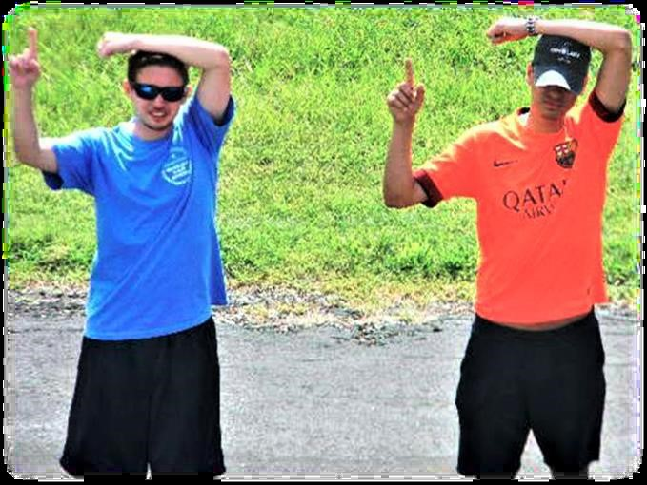
Alert pilots of a hidden powerlines using the new hand signaling procedure. The arm bent over the top of one’s head will now be recognized as the universal indicator of a power/phone line. The other arm is used to get the pilot’s attention and to point to the hazard. The pilot could even communicate back with the same gesture to crew that the warning was received. Please spread the word on this new safety initiative as it could no doubt prevent an accident in our ballooning community. Thanks to Mike Hance who first brought this idea to the BFA and balloon events in Texas.

FAA Approved Waiver & Special Provisions

The FAA Waiver and Special Provisions will be posted to the US Nationals and the Great Texas Balloon Race Young Guns Electronic Notice Boards at www.watchmefly.net

For the Great Texas Balloon Race, a copy of the FAA waiver and Special Provisions will be provided to you at pilot registration.

All pilots will be required to sign a FAA document that they understand the FAA waiver and Special Provisions during pilot registration.

Propane Refueling

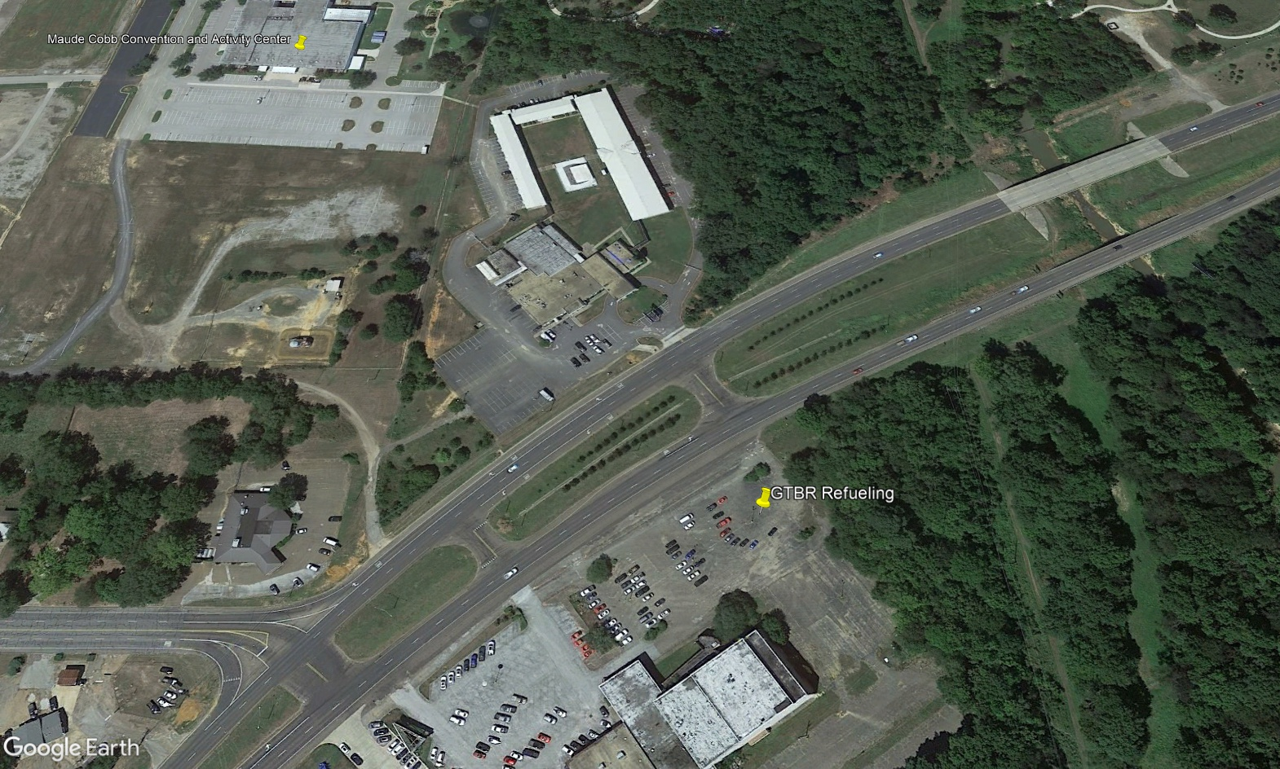

Propane Refueling will be located on the south side of Hwy 31 just south of the Competition Center at the Maude Cobb Convention and Event Center.

The manifold will be in the northeast corner of the closed theater building parking lot.

The opening and closing times of the refueling area is listed in the master schedule.

Pilot Rosters

US Nationals

1. Rhett Heartsill 50. Mark Sullivan
2. Joe Heartsill 51. Elisa Talbert
3. John Petrehn 52. Steve Wilkinson
4. Chase Donner 53. Bruce Wood
5. Lucas Heartsill 54. Marc Blaser
6. Branden Bloom
7. Joe Zvada
8. Cameron Wall
9. Jonathan Wright
10. Zerek Welz
11. Blake Aldridge
12. Allen Anderson
13. Scott Armstrong
14. Jeff Ashworth
15. Cory Bloom
16. Bill Bussey
17. Gary Cass
18. Bret Christian
19. Leroy Clair
20. Phil Clinger
21. Patrick Cloyd
22. Brad Craig
23. Bill Cunningham
24. Jim Cusick
25. Nick Donner
26. Ken Draughn
27. David Eichhorn
28. Matt Fenster
29. Brandon Heavin
30. Gary Heavin
31. Todd Isley
32. Jason Jones
33. Steve Jones
34. Eric Martens
35. Collin McClung
36. Al Nels
37. Andrew Nels
38. Patrick Nilz
39. Rob Nutting
40. Paul Petrehn
41. Grant Pfeifer
42. Shawn Raya
43. Matt Riley
44. Jeremy Rubin
45. Richard Sabin
46. Kasey Schwemmer
47. Joe Seymour
48. Shawn Speicher
49. Natasha Stanke
Great Texas Balloon Race Young Guns

1. Trenten Caldwell
2. Morghan Chando
3. Spencer Copas
4. Ryan Duff
5. Duncan Hernandez
6. Maddie Jones
7. Geoffrey Jones
8. Ben Leatherman
9. Jacob Little
10. Zackery Maxwell
11. Andy Schraufnagel
12. Lillian Speicher
13. Joey Strutz
14. William Vavra
15. Eric Wiggins

Great Texas Balloon Race

1. Bill Baker
2. Pat Cannon
3. Guy Gauthier
4. Joshua Goll
5. Robert Gonzales
6. Pat Harwell
7. Rick James
8. Shawn Kraus
9. Steve Lombardi
10. Joe Paddie
11. Bob Pulaski
12. Sam Robey

Special Shape Balloons

1. Bill Broker
2. Amie Cato
3. Josh Cato
4. Ben Drennan

